Line and Box Judging:

Flyball Tournament

Hosted by Texas Twisters
Saturday Tournament, February 15, 2020
Sunday Tournament, February 16, 2020
Judges – Steve Corona & Mike Smith
Tournament Director – Judy Walter
Regional Director – Mike Smith
First, thanks to everyone who will be helping with line and box judging! We couldn’t put on a tournament without you!
If you find that you will be unable to fill a seat during your assigned judging slot, please let the current table worker know so that we can find someone to take your place.
Racing:
- We have planned for a fun, relaxed tournament. Of course, promptness is always appreciated.
- We will have 2 minute warm ups - both Saturday and Sunday until every team has raced once, then we will go to 1 minute warm ups.
- We will have solo and duo racing during the breaks and green dog training during lunch both days.
If your team is finished warming up before the 2 minutes, please let the judge know so we can get the race started. Thanks!
After warm up, if your team would like a practice start, please let the judge know during the warm up period. As a reminder, props may be used during the practice start as it is considered part of the warm up.
Timeline
Remember that this weekend is 2 separate tournaments Saturday and Sunday.
Friday Time Line

9:00 – 3:00 set up

Crating 1:00 – 7:00pm – Unless you are helping with set up or racing, please do not arrive any earlier than 1:00pm.
4:00 – 7:00 Friday mat time.

Saturday Time Line

6:00 - Building opens
7:00 – 7:45 Check-in
7:30 - Measuring
7:45 - Captain’s Meeting
8:00am - Racing Begins
40 minute lunch around 11:30
We will let you know on the racing schedule what race number lunch will follow.

Sunday Time Line

6:00 – Building opens
7:00 – 7:45 Check-in
7:30 - Measuring
7: 45 – Captain’s Meeting
8:00am – Racing Begins
30 minute lunch around 11:30
We will let you know on the racing schedule what race number lunch will follow.

Photo Opportunity

We will have a photo set up for you to be able to take photos with you and your dogs or just your dogs. Please feel free to come to the back for a great photo opportunity!

Introducing the 1st Flyball BINGO!!

Ever get a little bored with all the breaks in flyball lately! We all really enjoy them for the green dog training and solos and duos……but what about when your dog isn’t out in the ring??

WELL!!! Try your hand in some Flyball BINGO!!!

Texas Twisters will offer everyone the chance to play Flyball Bingo!

FLYBALL

LYBALL

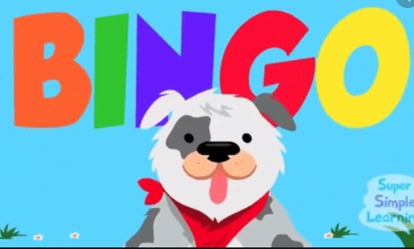

Simple to play: Each person can purchase as many bingo cards as they want!
1 card = $10 or 2 cards = $15

During the tournament, our bingo person will draw out a number of bingo flyball related words from a jar and list them on our poster of over 275 words. Bring your bingo cards up to the poster whenever you have a break and check to see if the words on your cards have been chosen – just like bingo! There are big prizes awarded to the first 3 people who get a bingo!

Dessert Buffet

Texas Twisters will be providing a huge dessert buffet for all participants on Saturday. After you finish your meal, come and join us in the kitchen area for banana pudding, cakes, pies, ice cream, cookies, fruit trays, valentine’s candy etc. There will be plenty for all!
Our treat from us to you!



Tournament Points:
The winner of each heat will receive one tournament point, and the winner of the majority of heats in a race will be awarded an additional two bonus points regardless of format.
Heats ending in a tie will result in each team receiving ½ of a tournament point.

If neither team wins the majority of heats, there will not be an extra heat ran, but both teams will split the 2 additional bonus points.

If neither team wins the majority of heats because of a double loss in one of the heats, there will not be an extra heat ran and neither team will receive bonus points.

The winners of the divisions with a modified single elimination will be determined after all races are finished in that division – including the races in the single elimination.
Division Tie Breakers:

1. Results of head to head competition at the heat level.
2. Fastest legal time in head to head competition.
3. Fastest legal time throughout the day’s competition.
4. Toss of a coin.

Crating: Crating map is up.
Parking: Parking is allowed on the north, east and south sides of the building. Please do not block off any of the bay doors or regular doors

Poop Area: The poop area will be located just to the south and west of the building in the grassy
areas.

We look forward to seeing everyone!

Texas Twisters Flyball

